

LICENSURE EXAMINATION FOR PROFESSIONAL TEACHERS
SEPTEMBER 20, 2026

GURONG PINOY: PROFESSIONAL EDUCATION REVIEWER
(Session 13: May 27, 2026)

1. A group that has clear roles and mutual respect is likely in which stage?
- Storming
- Norming
- Forming
- Adjourning

TUCKMAN'S STAGES OF GROUP DEVELOPMENT (FSNPA)
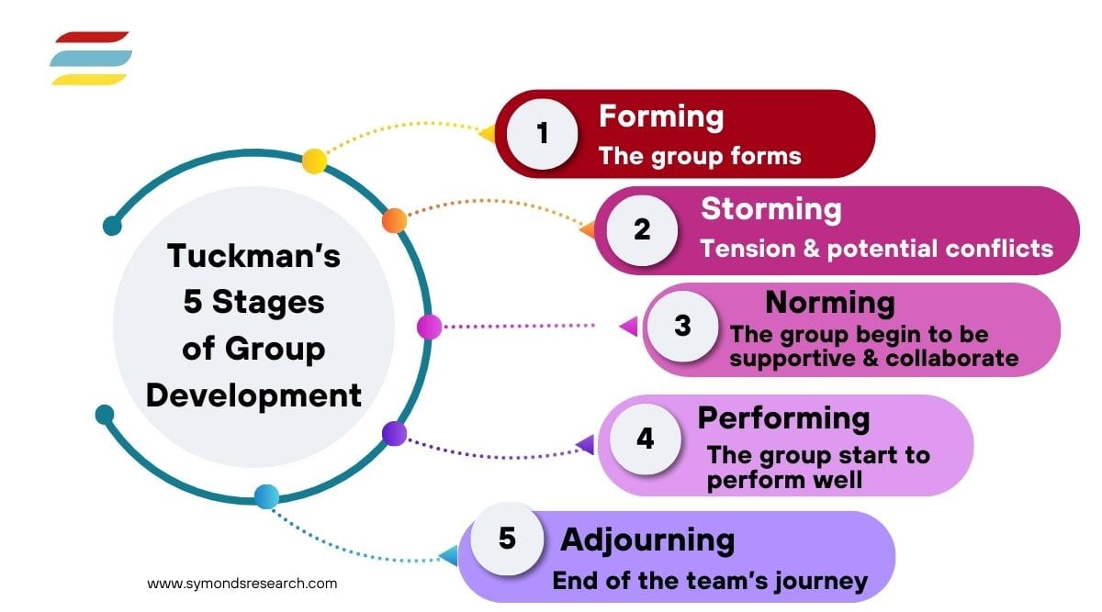

Stage | Key Characteristics / Description
Forming | Members are still adjusting to each other and the team.
Storming | Conflicts, disagreements, and misunderstandings happen.
Norming | Roles become clear; cooperation and mutual respect develop.
Performing | The group becomes highly productive and works well together.
Adjourning | The group completes its tasks and disbands.




STAGES OF GROUP DEVELOPMENT
Bruce Tuckman
(explains how a team forms)

2. In the constructivist approach, the following are the roles of a teacher EXCEPT
- Scaffolds and guides
- Warm demander
- Empowering model
- “Sage on the stage”

3. Sexual urges remain repressed and children mostly interact with same-sex peers. These instances are under the
- Anal Stage
- Latency Stage
- Phallic Stage
- Genital Stage
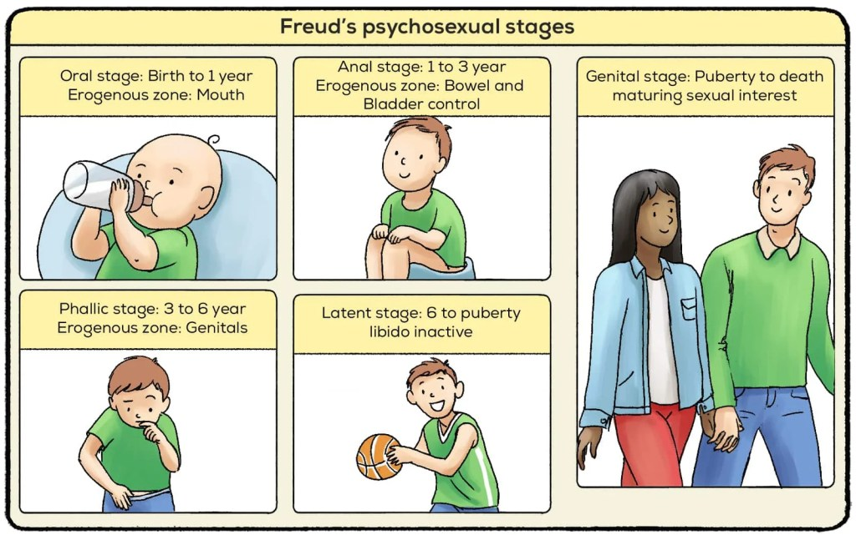

4. Based on Freud’s theory, which operates when a student hits a classmate at the height of anger?
- Id
- Ego
- Id and Ego interact
- Superego
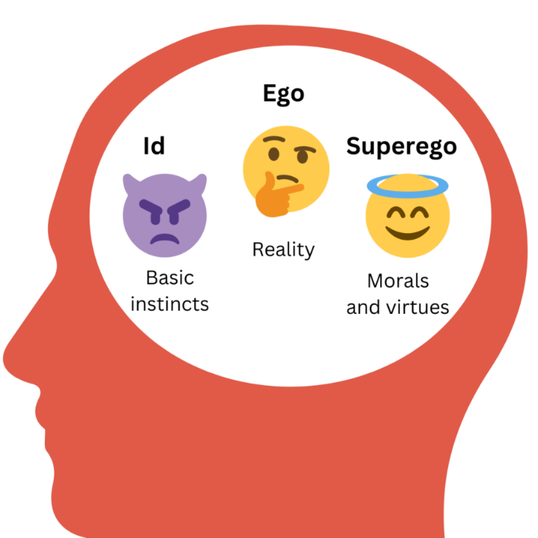
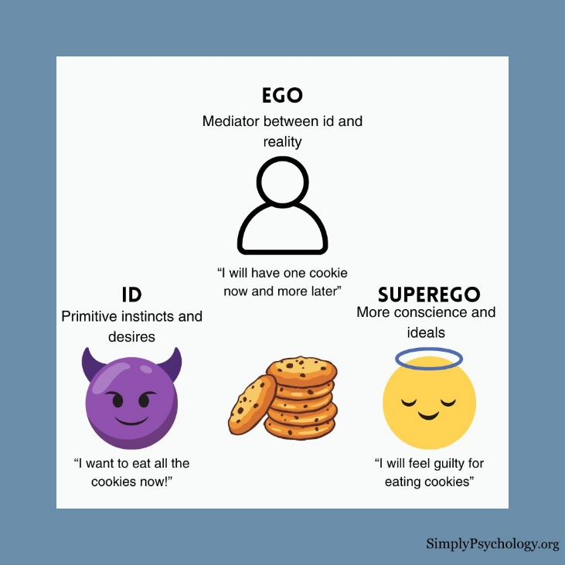

5. A school wants to develop the learners’ metacognitive skills. Which practice is inconsistent with the school’s goal?
- Rote teaching
- Emphasis on HOTS
- Constructivist instruction
- Authentic assessment

6. Rizza knows that when their family goes out for dinner, she needs to follow certain rules and mind her manners at the table. Such set of standards is an example of
- Pre-conventional rule
- Conventional rule
- Post-conventional rule
- Between pre-conventional and conventional rule
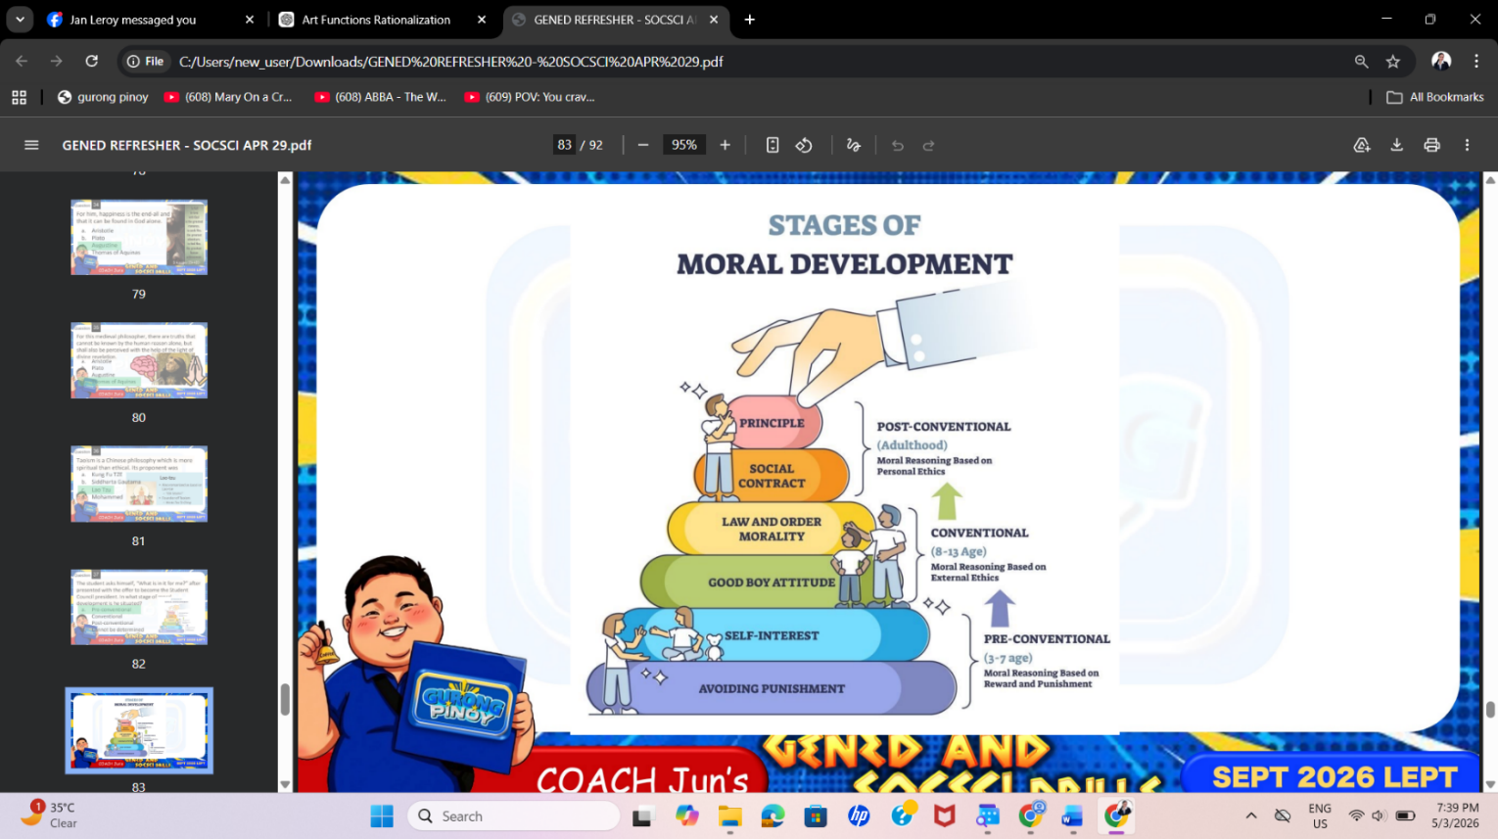
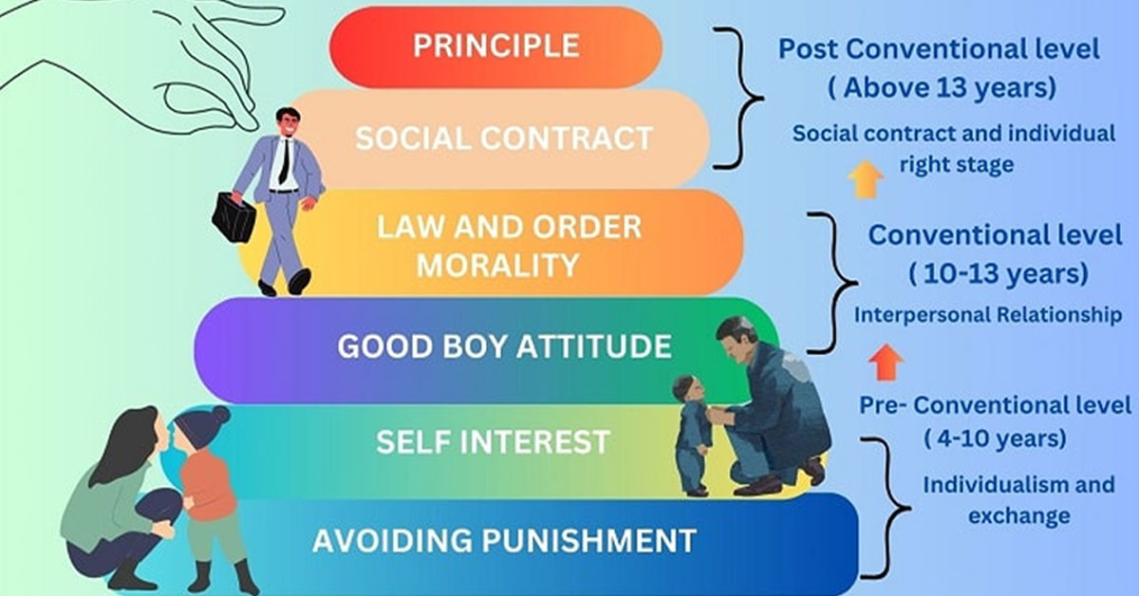

7. Which teachers benefit from professional development?
- New teachers and bad teachers because they don't know what they are doing.
- Veteran teachers because they need to stay up to date on new technology and research.
- Good teachers because they will apply what they learned and become even better
- All teachers need and benefit from professional development in the areas they are weakest.

